This is SQL server 19 evaluation edition:

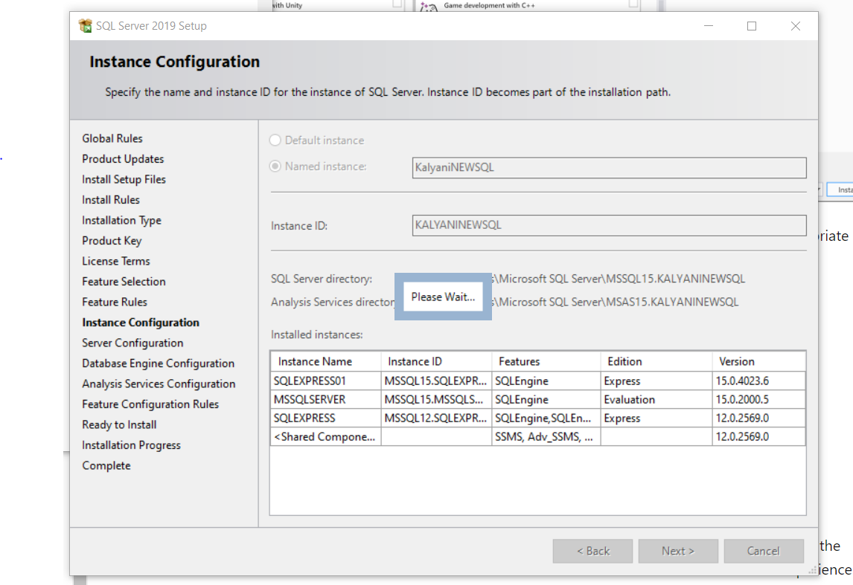

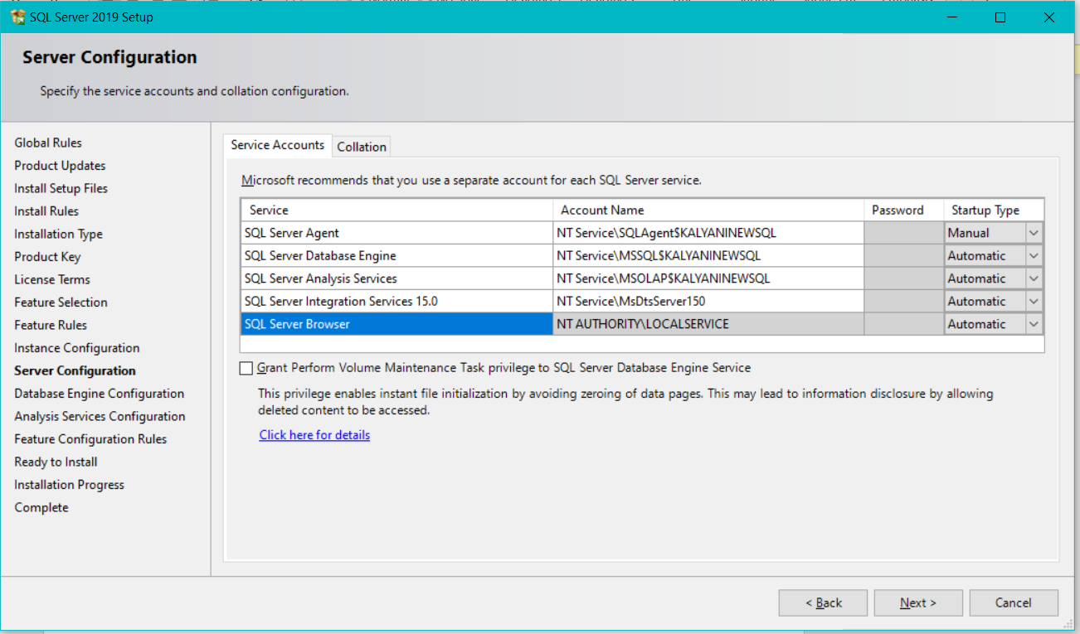

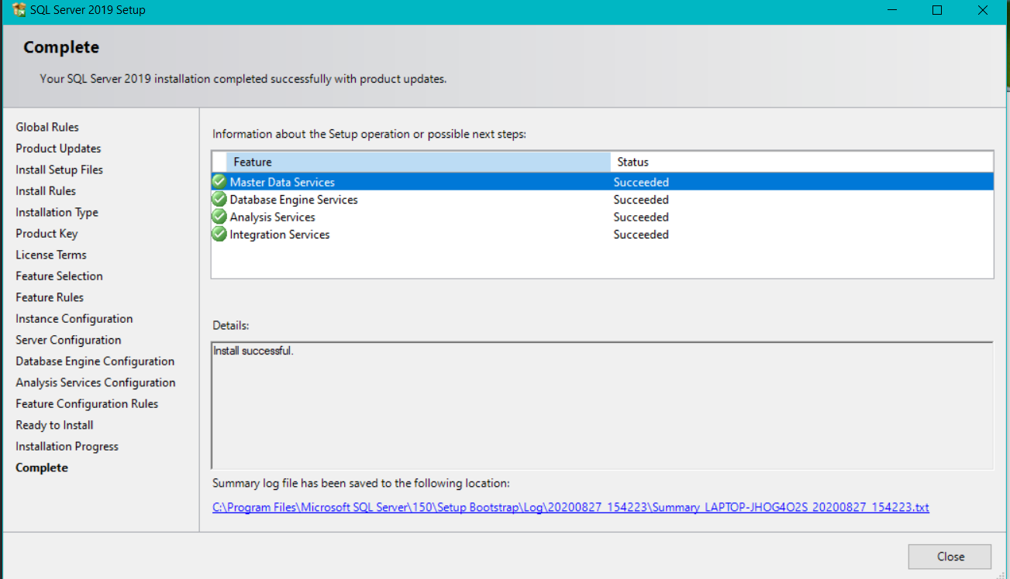

We've discontinued the SSDT standalone installer for Visual Studio 2019. For Visual Studio 2019, you now can get the SSIS designer extension from the [VS market place](https://marketplace.visualstudio.com/items?itemName=SSIS.SqlServerIntegrationServicesProjects&ssr=false#overview). OR I used extensions tab in visual studio to add new features.

